Synopsis

Prediction of Congestion in Campus Wi-Fi Networks using Machine Learning

Project Id:
Problem Id:

Student Name : Simran Kundiyal
University Roll number : 2519528
Section : X

Student Name : Yash Negi
University Roll number : 2519577
Section : X

Index

S.No. Title Page No.

- Problem Description 3
1.1 Dataset Description 4
1.2 Flow Diagram 5
- Modules for Project Implementation 6
2.1 Modules Used 6
2.2 Platform Used 7
- Machine Learning Models Used 8

- Evaluation metrics used 10

- Results And Visualizations 11

- Conclusion and Future Scope 13

- References 14

1. Problem Description:

The increasing dependence on wireless networks in educational campuses has led to a significant rise in network congestion issues. With a large number of users simultaneously accessing Wi-Fi services for academic, streaming, and communication purposes, maintaining optimal network performance has become a critical challenge. Congestion in Wi-Fi networks results in increased latency, packet loss, and reduced bandwidth availability, negatively affecting user experience.
In this project, an end-to-end machine learning classification system is designed and developed to analyze and predict Wi-Fi congestion in a campus environment. The system uses a dataset consisting of network performance parameters such as number of connected devices, network latency (ms), packet loss rate (%), bandwidth usage (Mbps), and access point load. The dataset is synthetically generated to mimic real-world conditions and includes variations, noise, missing values, and outliers to enable realistic analysis.
The pipeline includes data preprocessing, exploratory data analysis (EDA), correlation analysis, feature selection (PCA, forward and backward selection), model training, and evaluation. The goal is to classify whether a given network state is congested or not, enabling proactive network management.

1.1. Dataset Description:
The system uses a dataset consisting of network performance parameters such as:
- Number of connected devices
- Network latency (in milliseconds)
- Packet loss rate (in percentage)
- Bandwidth usage (in Mbps)
- Access point load
Sample dataset -
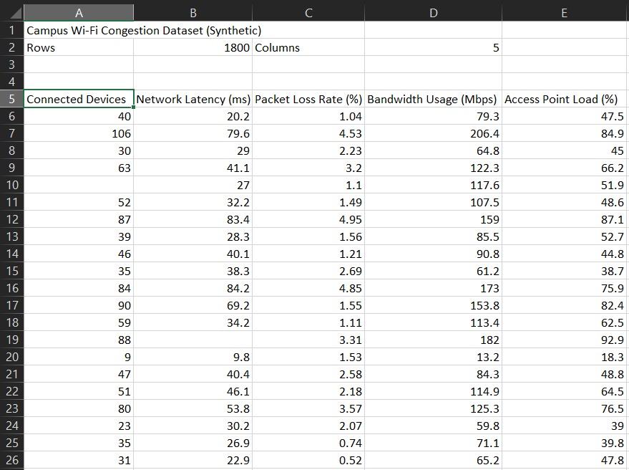
The dataset used for this project is a synthetically generated Wi-Fi network dataset, designed to closely mimic real-world network conditions. It includes variations, noise, missing values, and outliers to simulate practical scenarios and enable realistic data analysis.

1.2. Flow Diagram:
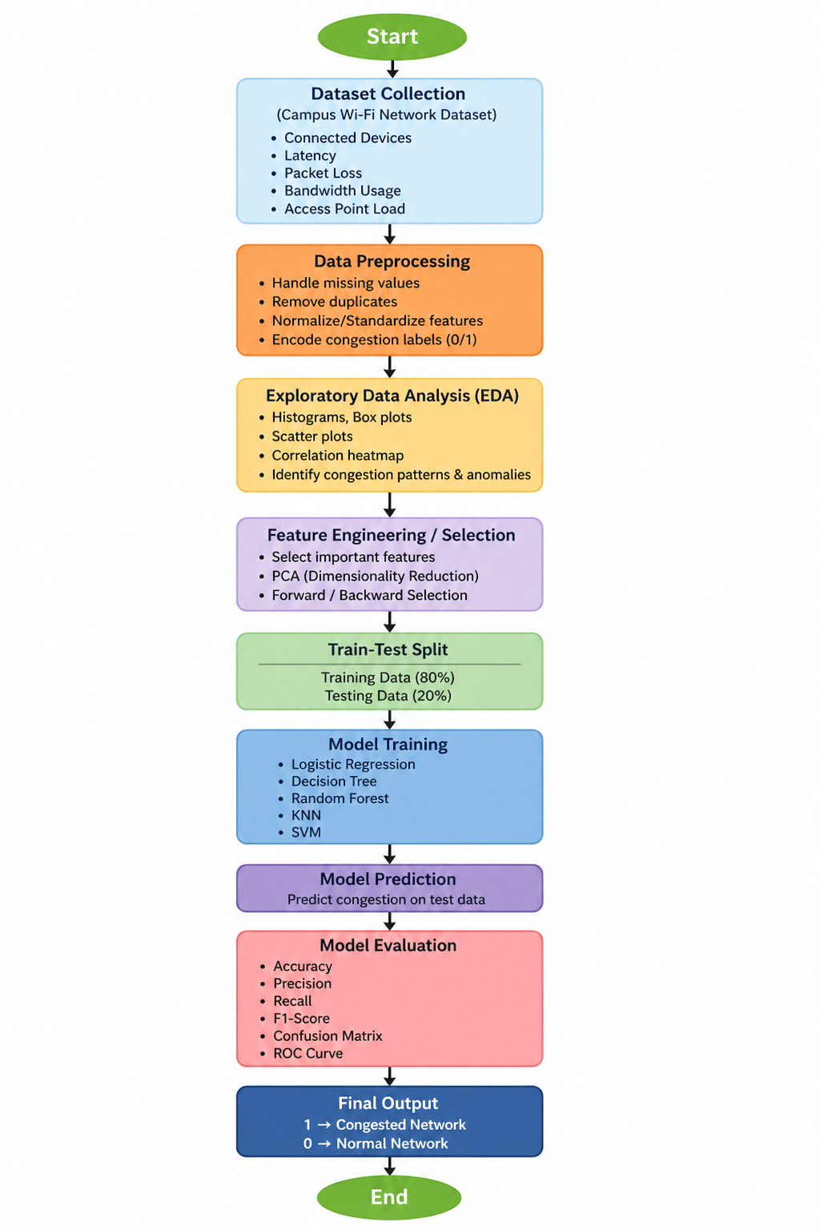
Fig. 1: Flow diagram of the proposed system.

2. Modules for Project Implementation:

2.1 Modules Used:

Pandas
Pandas is used for data manipulation and analysis, enabling efficient handling of structured data. It helps in cleaning, organizing, and summarizing the Wi-Fi dataset. For example, it can be used to compute average latency or filter rows with high packet loss.

NumPy
NumPy supports numerical computations and array operations. It is used for mathematical transformations and scaling of features such as latency and bandwidth usage before model training.

Matplotlib
Matplotlib is used for basic data visualization such as histograms and line plots to understand data distribution and trends in network usage.

Seaborn
Seaborn provides advanced visualizations like heatmaps and box plots. It is useful for correlation analysis between network features and identifying congestion patterns.

Scikit-learn
Scikit-learn is used to build and evaluate machine learning models including Logistic Regression, Random Forest, and SVM. It also helps in preprocessing and splitting the dataset.

2.2. Platform Used:

Jupyter Notebook is used as the primary platform for implementing the project. It provides an interactive environment for writing and executing Python code, performing data preprocessing, and conducting Exploratory Data Analysis (EDA). It also supports visualization libraries like matplotlib and seaborn, making it suitable for analyzing and presenting Wi-Fi network data effectively.

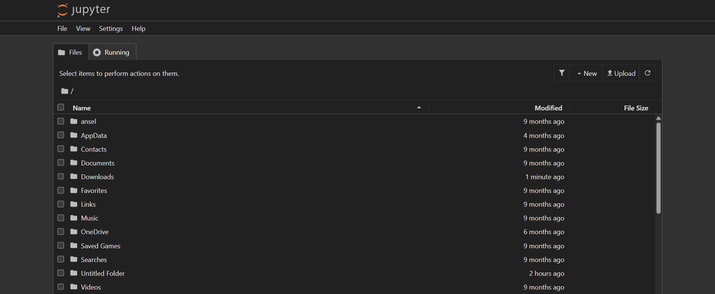

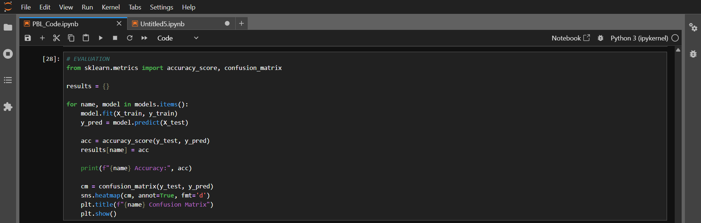

3. Machine Learning Models Used

Logistic Regression
A statistical classification algorithm that predicts the probability of Wi-Fi congestion using a sigmoid function. It is simple, fast, and effective for baseline performance in binary classification problems.

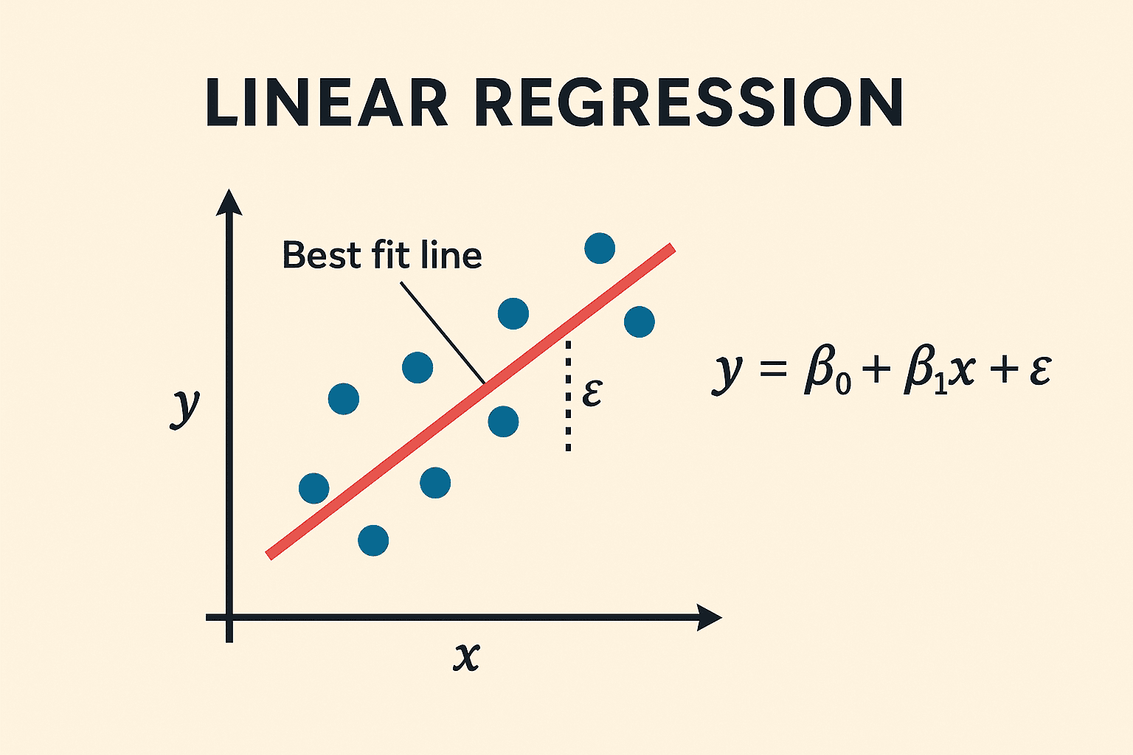

Random Forest Classifier
An ensemble learning technique that builds multiple decision trees and combines their outputs for better accuracy. It handles complex relationships between features like latency, packet loss, and bandwidth, and reduces overfitting.
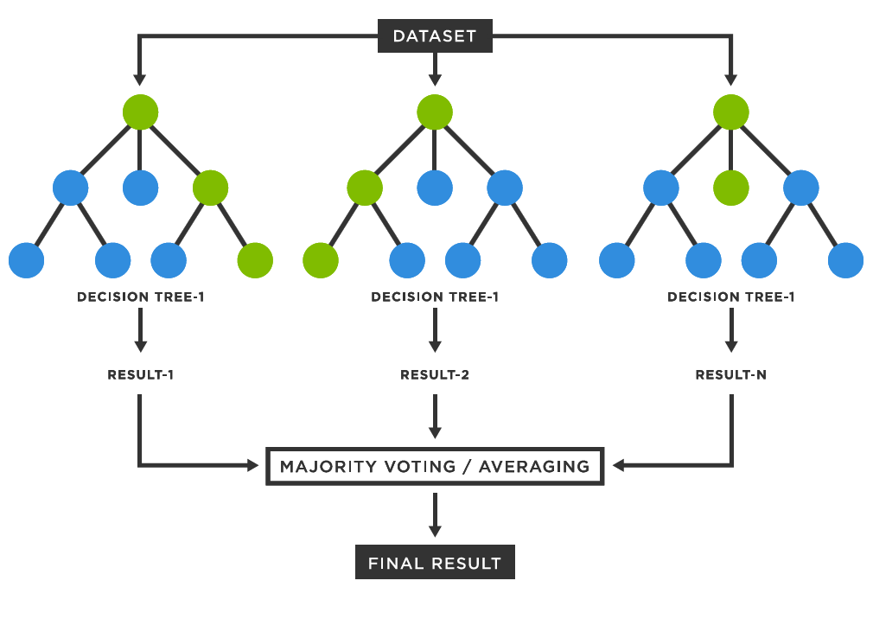

Support Vector Machine (SVM)
A powerful algorithm that finds the optimal hyperplane to separate congested and non-congested classes. It performs well in high-dimensional data and can model non-linear boundaries using kernel functions.

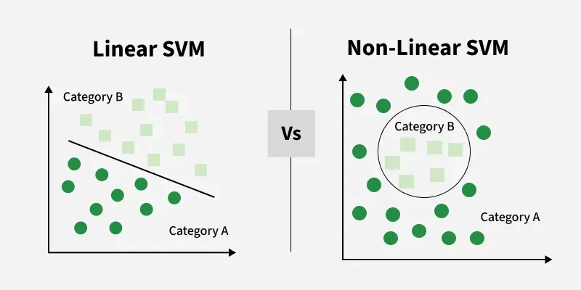

4. Evaluation Metrics Used

Accuracy
Accuracy measures the percentage of correctly predicted instances.
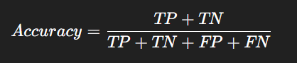
Confusion Matrix
A confusion matrix shows:
- True Positive (TP)
- True Negative (TN)
- False Positive (FP)
- False Negative (FN)

Importance:
- Helps analyze model performance
- Identifies misclassification
Heatmap (Confusion Matrix Visualization)
A heatmap visually represents the confusion matrix using colors.
Advantages:
- Easy interpretation
- Detects errors quickly

5. Results And Visualizations
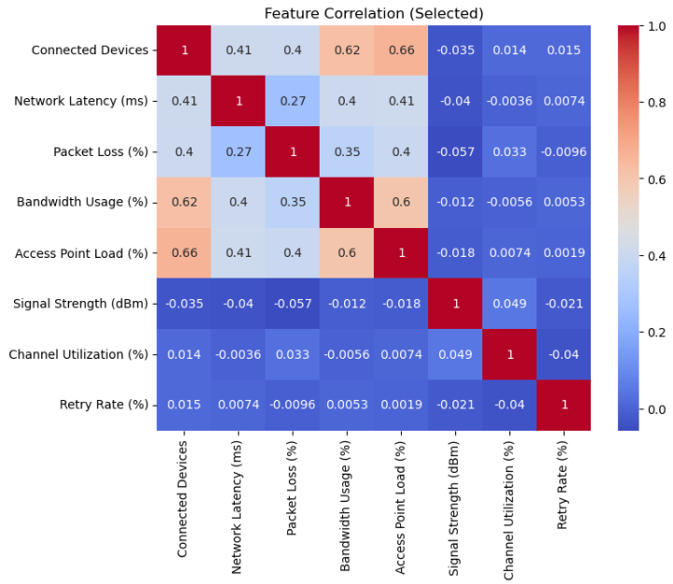
Fig 2: Figure Showing Heatmap of Feature Correlation
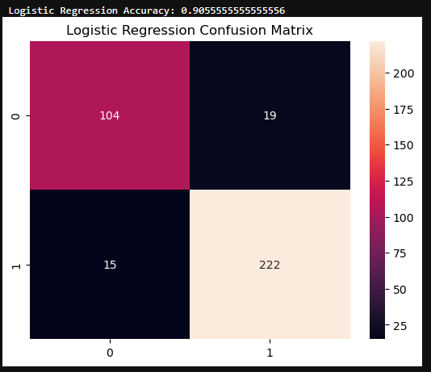
Fig 3: Figure Showing Logistic Regression Confusion Matrix and Accuracy
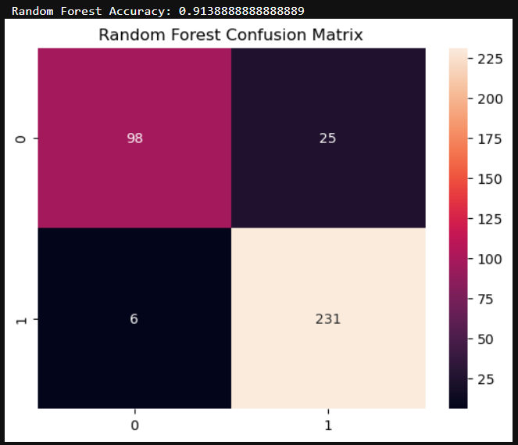
Fig 4: Figure Showing Random Forest Confusion Matrix and Accuracy
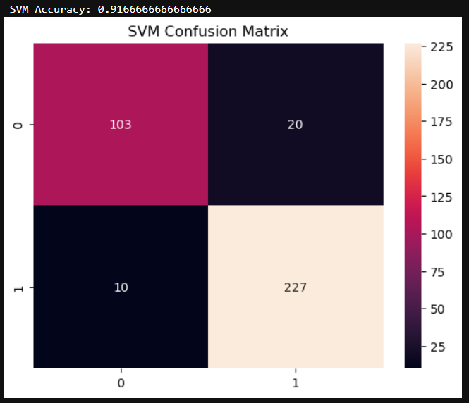
Fig 5: Figure Showing SVM Confusion Matrix and Accuracy

6. Conclusion and Future Scope
This project successfully developed a machine learning-based system to predict Wi-Fi congestion. The system effectively analyzes network parameters and identifies congestion patterns.
- Random Forest provided the best accuracy
- EDA helped in understanding data patterns
- Feature selection improved performance
Future improvements include real-time deployment and deep learning integration.

Future Scope
- Use real-time data from campus routers
- Implement deep learning models
- Deploy system as a web application
- Integrate with network monitoring tools

7. References

Books
- Let Us Python – Yashavant Kanetkar

Online Resources
- Scikit-learn Official Documentation (ML Models & Preprocessing)
https://scikit-learn.org/stable/
Covers data preprocessing, feature selection methods (PCA), and classification algorithms like Logistic Regression, SVM, KNN, etc.
- Kaggle Learn (Practical ML & EDA Tutorials)
https://www.kaggle.com/learn
Offers hands-on tutorials on data preprocessing, EDA, feature engineering, and machine learning workflows.
- Official Seaborn Heatmap Documentation
https://seaborn.pydata.org/generated/seaborn.heatmap.html
Explains how to use heatmaps in seaborn library
- Chat GPT
https://chatgpt.com/

